**CHAPTER 1 – INTRODUCTION**

* 1. **Introduction to Project**

The "D-controller" project aims to develop a comprehensive Ground Control Station (GCS) application that enables the control and monitoring of drones. The GCS serves as a central hub, providing real-time telemetry data, dynamic mode and parameter changes, mission planning capabilities, map integration, waypoint drawing, and live video streaming.

This chapter provides an introduction to the project, highlighting its significance and objectives.

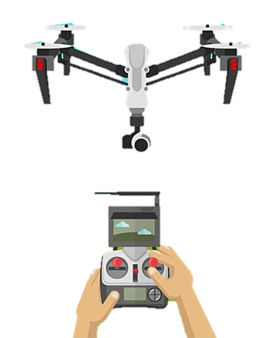

TRANSMITTER RADIO CONTROLLER

SOFTWARE (GCS)



DRONE

*Figure 1.1 shows the drone and transmitter with attached GCS Software*

By utilizing the capabilities of Dronekit, Pymavlink, and PyQt5 libraries, the D-controller offers an intuitive and efficient means of managing drone operations.

* 1. **Project Category**

This project falls under the category of Application or System Development.

It focuses on the development of a specialized GCS for drone control, catering to the needs of various industries, including aerial photography, surveillance, agriculture, and delivery services.

The project combines the utilization of technologies, frameworks, and libraries to create an efficient and user-friendly GCS solution.

* 1. **Objectives**

The primary objectives of the project are as follows:

* Develop a robust GCS application capable of controlling and monitoring drones.
* Provide real-time telemetry data for tracking and analyzing the drone's performance.
* Enable users to change the drone's mode and parameters dynamically.
* Implement mission planning functionality to create and execute autonomous flight paths.
* Display the drone's location on a map interface for enhanced situational awareness.
* Allow real-time waypoint drawing on the map to facilitate precise mission planning.
* Stream live video feed from the drone's camera for remote monitoring and surveillance purposes.
  1. **Problem Formulation**

The project addresses the need for an advanced GCS solution that overcomes the limitations of existing applications.

Many GCS applications available today lack certain features or have complex user interfaces, making it challenging for users to control the drone effectively and access real-time information.

The "D-controller" project aims to bridge this gap and provide a comprehensive solution that enhances the drone control experience.

* 1. **Identification/Reorganization of Need**
* The increasing popularity and application of drones in various industries have created a demand for efficient and user-friendly GCS applications.
* It is crucial to have a reliable system that allows users to control and monitor drones seamlessly, ensuring safe and efficient operations.
* The "D-controller" project recognizes this need and strives to provide a specialized GCS solution tailored to the requirements of drone control.
  1. **Existing System**
* The current market offers several GCS applications such as Mission Planner, QGroundControl, and Ardupilot.

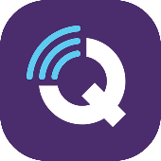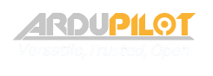

* While these applications provide some of the required functionalities, they may lack certain features or have complex interfaces.
* The "D-controller" project aims to address these limitations and provide an improved GCS solution that offers a comprehensive set of features and a user-friendly interface.
  1. **Proposed System**
* The proposed system, "D-controller," is an easy GCS application that integrates with drone systems to provide enhanced control and monitoring capabilities.
* It offers a wide range of functionalities, including real-time telemetry data monitoring, dynamic mode and parameter changes, mission planning, map integration, waypoint drawing, and live video streaming.
* The "D-controller" project aims to enhance the user experience and provide a comprehensive solution for efficient drone control.
  1. **Scope of the Project**
* The project's scope encompasses the development of the "D-controller" GCS application, including its software architecture, user interface design, integration with Dronekit, PyMavlink, PyQt5, and other relevant libraries.
* The application will be designed to run on compatible hardware platforms and provide the specified features and functionalities.
* Additionally, the project will involve testing, debugging, and performance optimization to ensure a reliable and efficient GCS solution.

**CHAPTER 2 - REQUIREMENT ANALYSIS AND SYSTEM SPECIFICATION**

**2.1 Feasibility Study**

A comprehensive feasibility study was conducted to assess the technical, economical, and operational aspects of the "D-controller" project.

The study aimed to determine the viability and practicality of developing the system.

Key areas of analysis included:

1. **Technical Feasibility:**

Assessing the technical resources, capabilities, and infrastructure required for developing the system. This involved evaluating the availability of necessary hardware, software, and development tools, as well as the compatibility with the targeted platforms.

1. **Economic Feasibility:**

Analysing the financial implications and cost-effectiveness of developing and maintaining the system. This included estimating the project costs, such as hardware, software, and development expenses, and evaluating the potential return on investment (ROI) or cost savings that the system could provide.

1. **Operational Feasibility:**

Evaluating the operational impact of the system on the intended users and stakeholders. This involved assessing the system's compatibility with existing processes, the ease of integration into the operational environment, and the potential benefits and challenges associated with its implementation.

**2.2 Software Requirement**

The D-controller application includes the following requirements:

1. **Data Requirements**: The application must be able to receive and display real-time telemetry data and video feed from the drone.
2. **Functional Requirements**: The application must be able to change the drone's mode, set parameters, and plan and execute missions.
3. **Performance Requirements:** The application must be able to communicate with the drone in real-time and display real-time data and video feed without significant lag.
4. **Dependability Requirements:** The application must be able to handle unexpected

events and errors without crashing or losing data.

1. **Maintainability Requirements:** The application must be designed to be easily maintainable and upgradable.
2. **Security Requirements**: The application must ensure the security of communication between the GCS and the drone.
3. **Look and Feel Requirements:** The application must have a user-friendly interface with intuitive controls and display.

**2.2.1 Hardware Requirements**

The "D-controller" software has the following hardware requirements:

1. **Processor**:

Intel Core i5 or equivalent, with a minimum clock speed of 2.4 GHz.

1. **Memory (RAM):**

Minimum 8 GB of RAM for optimal performance.

1. **Storage:**

At least 100 MB of free disk space for software installation.

1. **Graphics Card:**

Any graphics card that supports OpenGL 3.0 or higher.

1. **Input Devices:**

A standard keyboard and mouse for general interaction. For advanced features, such as joystick control, a compatible joystick or controller is required.

1. **Network Requirements:**

The software requires a stable internet connection for real-time telemetry data, map integration, and video streaming features. A minimum network bandwidth of 5 Mbps is recommended for optimal performance.

1. **Other Hardware:**

A drone with compatible communication modules, such as a Pixhawk flight controller, is required for establishing a connection and controlling the drone using the software.

**2.3 Validation**

The SRS document will be used as a basis for testing and validation of the D-controller application. The application will be validated through testing and user feedback to ensure that it meets all the specified requirements.

**2.4 Expected Hurdles**

The main expected hurdles during development include difficulties in communication with the drone, unexpected errors, and compatibility issues with different drone models.

**2.5 SDLC Model to be used**

The Agile SDLC model will be used for the development of the D-controller application. This model allows for flexibility and adaptability in response to changing requirements and unexpected challenges. The development process will be iterative and will involve continuous testing and feedback to ensure the application meets the specified requirements.

**CHAPTER 3 - SYSTEM DESIGN**

**3.1 Design Approach**

For the design of the "D-controller" project, an object-oriented design approach was adopted. Object-oriented design focuses on organizing the system's components into objects that encapsulate data and behaviour.

This approach promotes modular and reusable design, allowing for easier maintenance, extensibility, and scalability of the system.

**3.2 Detail Design**

The detail design of the D-controller application will involve breaking down the system into smaller, more manageable components and defining the interactions between them. This will ensure that each component is well-defined and can be developed and tested independently.

**3.3 System Design**

To facilitate the system design process, various structured analysis and design tools were utilized, including:

1. **Data Flow Diagrams (DFDs):**

DFDs were used to depict the flow of data within the system and the processes that manipulate the data.

They provided a visual representation of the system's data processing and helped in identifying the system's inputs, outputs, and data transformations.

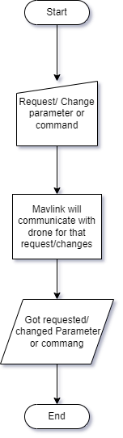

*Figure 3.1 shows the data flow diagram of D controller*

1. **Data Dictionary:** A data dictionary was created to define and describe the data elements used in the system. It provided a centralized reference for data definitions, data types, and data relationships.
2. **Structured Charts:** Structured charts, such as structure charts or class diagrams, were employed to illustrate the system's hierarchical structure and the relationships between different components.

They aided in understanding the system's architecture and the interactions between various modules.

1. **Flowcharts or UML:** Flowcharts or Unified Modelling Language (UML) diagrams, including use case diagrams, sequence diagrams, and activity diagrams, were used to represent the system's behaviour and process flows.

These diagrams helped in visualizing the system's functionality and the interactions between users, components, and external systems.

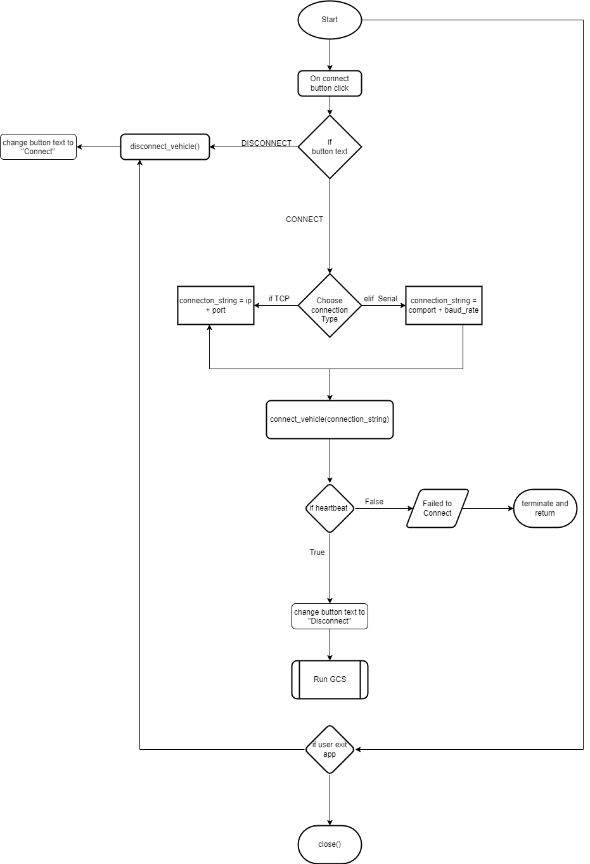

*Figure 3.2 shows the basic connection flow chart of D controller*

**3.4 User Interface Design**

The user interface of the D-controller application will be designed to be user-friendly and intuitive. It will have clear and concise controls for changing drone modes, parameters, and mission planning. The user interface will be designed using Qt Designer and PyQT5 libraries.

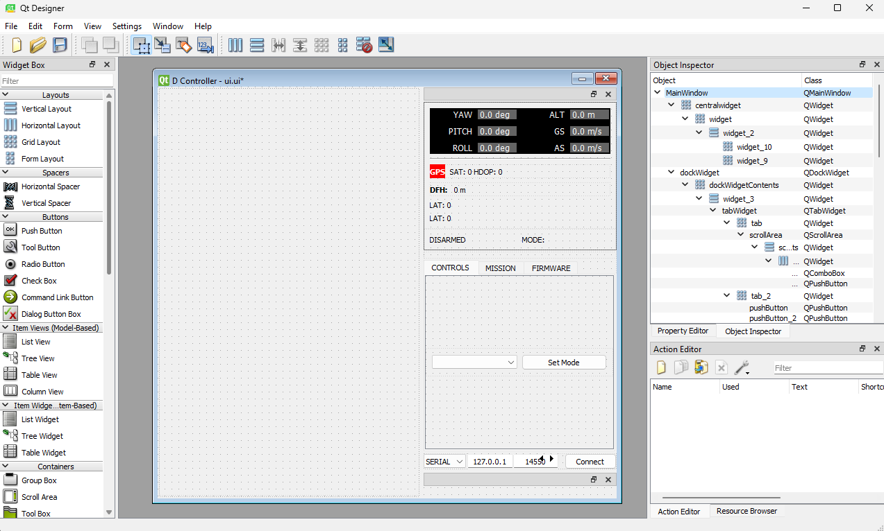

*Figure 3.3 show the user interface design of D Controller*

**3.5 Database Design**

As the "D-controller" project does not require a dedicated database, the database design was minimal.

**3.6 Methodology**

During the system design phase, a systematic and iterative approach was followed to ensure a robust and efficient design, this included:

1. **Requirement analysis:** Gathering and analysing project requirements to understand the system's objectives and functionalities.
2. **Design prototyping:** Creating prototypes and mock-ups to visualize the system's layout, interactions, and user interface.
3. **Iterative refinement:** Iteratively refining the design based on feedback, usability testing, and incorporating changes and enhancements to meet the project's objectives.

**CHAPTER 4: IMPLEMENTATION, TESTING, AND MAINTENANCE**

**4.1 Introduction to Languages, IDE's, Tools, and Technologies used for Implementation**

Our project implementation involved the utilization of several languages, IDE's, tools, and technologies to develop a robust and functional system. The following are the key components:

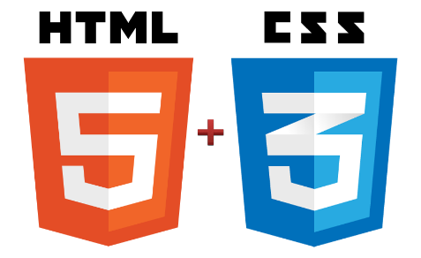 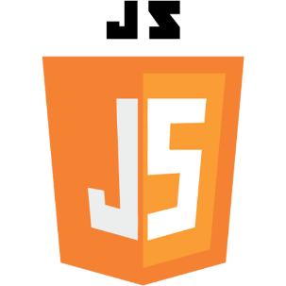 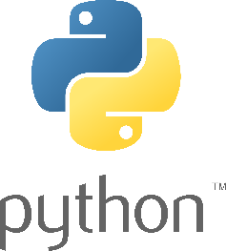

**4.1.1 Languages:**

1. **Python:**

Python was the primary language used for developing the backend logic and functionality of the system. Its versatility, extensive library support, and ease of use made it an ideal choice for our project.

1. **JavaScript:**

JavaScript was employed for implementing interactive and dynamic elements on the user interface. It enhanced the user experience and facilitated real-time updates on the web-based components.

1. **HTML:**

HTML (Hypertext Markup Language) was used to create the structure and layout of web pages, ensuring proper rendering and presentation of content.

1. **CSS:**

CSS (Cascading Style Sheets) was utilized to enhance the visual appearance of the user interface by applying styles, layouts, and formatting to the HTML elements.

**4.1.2 IDE (Integrated Development Environment):**

1. **Visual Studio Code:**

We utilized Visual Studio Code as our preferred IDE for coding and development. It offers a rich set of features, such as syntax highlighting, code completion, debugging, and version control integration.

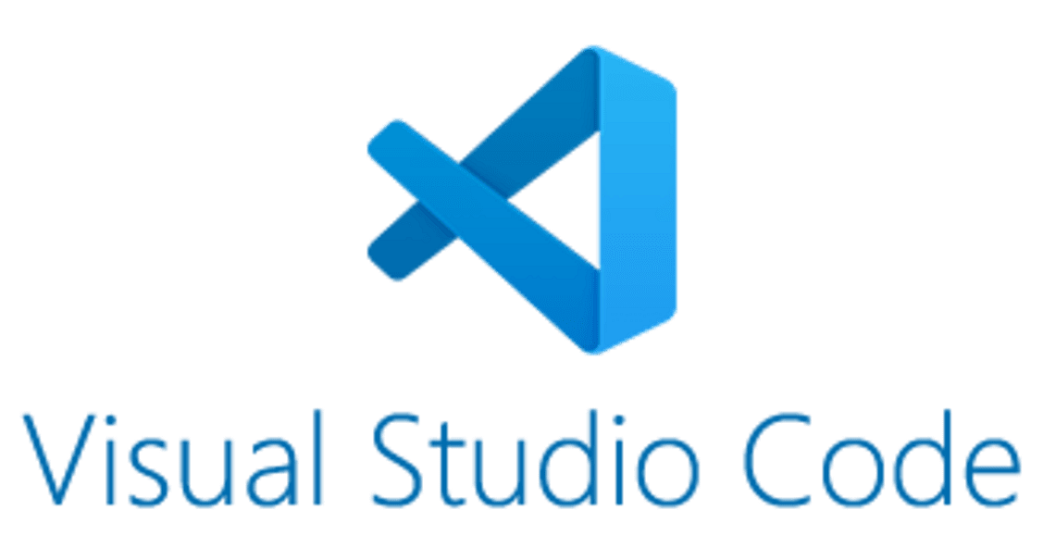

**4.1.3 Tools:**

1. **Qt Designer:**

Qt Designer was used for designing the graphical user interface (GUI) of our application. It provided a drag-and-drop interface for creating interactive UI components and defining their properties.

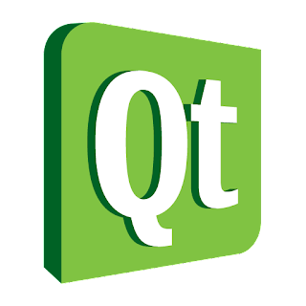

* + 1. **Technologies:**

1. **PyQt5:**

PyQt5, a Python binding for the Qt framework, was employed to develop the graphical user interface of our application. It enabled seamless integration of Python code with Qt functionalities.

1. **Qt WebEngine:**

Qt WebEngine allowed us to embed web content within the application, enabling features like real-time map display and web-based interaction.

1. **OpenCV:**

OpenCV (Open-Source Computer Vision Library) played a crucial role in handling video processing and image analysis tasks. It provided various algorithms and tools for image manipulation, object detection, and video streaming.

1. **Leaflet Map API:**

We utilized the Leaflet Map API to integrate interactive maps into our application. It facilitated the real-time display of drone locations and allowed users to interact with the map for mission planning.

1. **Pyautogui:**

Pyautogui was utilized to automate certain tasks related to the drone control and user interface interactions. It enabled programmatically controlling mouse and keyboard inputs for enhanced usability.

1. **Dronekit:**

Dronekit provided a powerful set of libraries and tools for communicating with the drone and sending commands. It facilitated real-time telemetry data retrieval, mode control, parameter changes, and mission planning.

1. **Pymavlink:**

Pymavlink served as a MAVLink protocol implementation in Python. It allowed communication between the ground control station and the drone, enabling command and control operations.

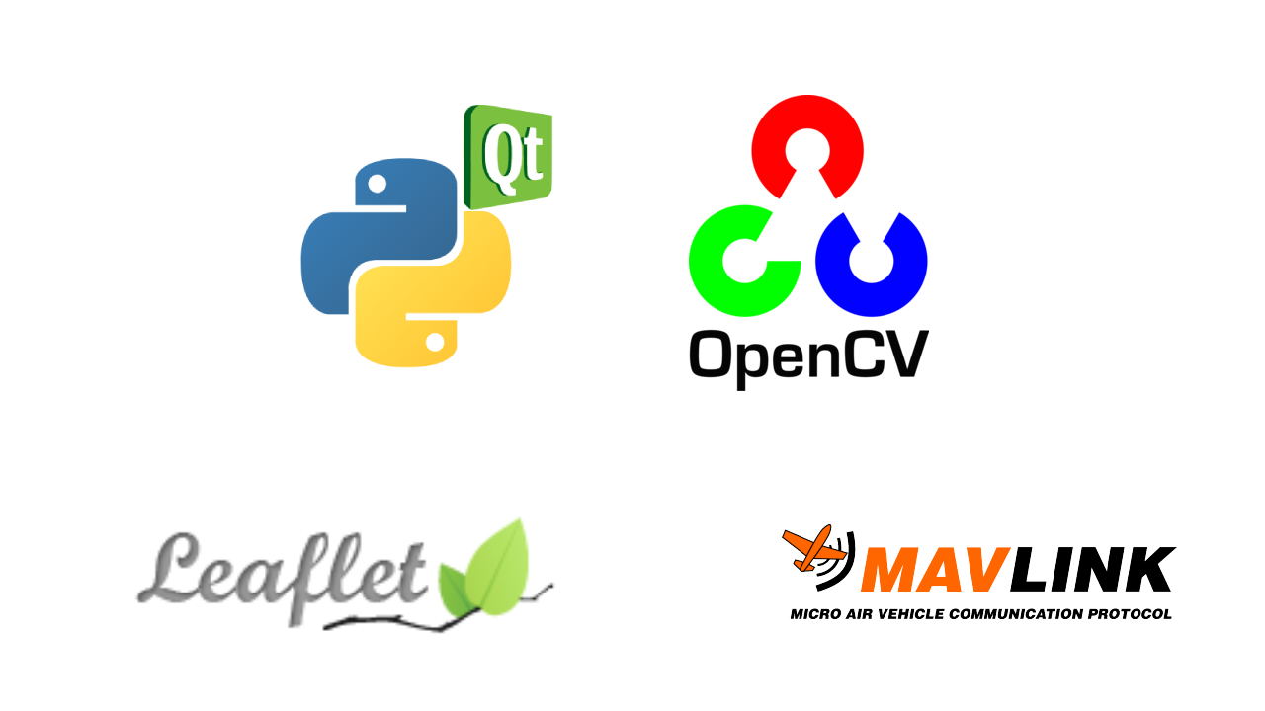

By leveraging these languages, IDE's, tools, and technologies, we were able to develop a comprehensive and feature-rich system that met the project requirements effectively.

**4.2 Coding Standards of Language Used**

To ensure consistent and readable code throughout our project, we have followed specific coding standards and conventions, as outlined below:

1. **Code Formatting:**

|  |  |
| --- | --- |
| Indentation: | We use a consistent indentation style, such as four spaces or a tab, to improve code readability. |
| Spacing: | We maintain consistent spacing around operators, parentheses, and braces to enhance code clarity. |
| Line Length: | We limit lines to a maximum length of 80 or 120 characters for better readability and ease of reviewing. |

1. **Comments and Documentation:**

|  |  |
| --- | --- |
| Inline Comments: | We include descriptive comments within our code to explain complex logic, algorithmic steps, or any non-obvious implementation details. |
| Function and Method Documentation: | We document the purpose, parameters, return values, and any important considerations for each function or method using appropriate documentation conventions. |
| File-level Documentation: | We provide a brief summary or introductory comments at the beginning of each source code file, describing the file's purpose and contents. |

1. **Naming Conventions:**

|  |  |
| --- | --- |
| Variables and Constants: | We use descriptive and meaningful names for variables and constants, following a consistent naming convention like camel case or snake case to enhance code understand ability. |
| Classes and Functions: | We use nouns or noun phrases for class names and verbs or verb phrases for function names to indicate their purpose and actions. |
| Abbreviations and Acronyms: | We avoid excessive use of abbreviations or acronyms unless they are widely recognized and commonly used. |

1. **Modularity and Reusability:**

|  |  |
| --- | --- |
| Modular Approach: | We encourage the decomposition of complex tasks into smaller, more manageable functions or classes to promote modularity and code reuse. |
| Separation of Concerns: | We follow the principles of separation of concerns by assigning specific responsibilities to different modules or components, making the code easier to understand and maintain. |

1. **Error Handling and Exception Handling:**

|  |  |
| --- | --- |
| Robust Error Handling: | We implement proper error handling mechanisms to gracefully handle exceptional situations, including appropriate error messages and logging mechanisms to aid in debugging. |
| Exception Types: | We use appropriate exception types for different error scenarios to provide meaningful feedback to users and facilitate error diagnosis. |

1. **Testing and Quality Assurance:**

|  |  |
| --- | --- |
| Testable Code: | We strive to write code that is modular and easily testable, enabling effective unit testing and verification of functionality. |
| Code Review and Quality Assurance: | We conduct code reviews to identify and rectify any code quality issues, ensuring adherence to coding standards and best practices. |

**4.3 Project Scheduling**

In our project, we utilized various tools and techniques for project scheduling to ensure smooth progress and timely completion. The following approaches were employed:

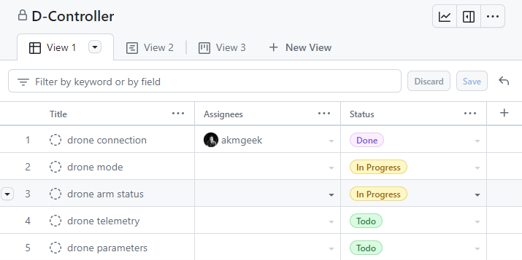

*Figure 4.1 shows the board scheduling of D Controller project*

**4.3.1 GitHub Project Board**

We leveraged the GitHub Project Board feature to create an organized and visual representation of our project tasks, milestones, and progress.

The GitHub Project Board allowed us to create different columns to represent different stages of the project, such as "To Do," "In Progress," and "Completed."

This board provided an overview of the tasks and helped us track the status of each task in real-time.

We utilized features like labels, due dates, and assignees to further enhance task management and assignment.

**4.3.2 GitHub Project Roadmap**

To provide a high-level overview of our project timeline and milestones, we developed a roadmap.

The roadmap outlined the major deliverables, key activities, and estimated timeframes for each phase of the project.

This visual representation allowed us to communicate the project plan to stakeholders and team members, enabling better coordination and understanding of project progress.

**4.3.3 Project Schedule Table**

In addition to the GitHub Project Board and roadmap, we created a project schedule table to capture the detailed breakdown of tasks, dependencies, start dates, end dates, and assigned resources.

This table provided a comprehensive view of the project timeline, task interdependencies, and resource allocation.

It helped us monitor task dependencies and identify critical paths to ensure efficient task sequencing and resource utilization.

By using these project scheduling tools and techniques, we were able to effectively plan and manage our project activities. The GitHub Project Board offered real-time visibility into task progress, while the roadmap provided a strategic overview of the project.

The project schedule table allowed us to monitor task dependencies and ensure timely execution. These scheduling approaches collectively contributed to improved project coordination, progress tracking, and timely completion.

**4.4 Testing Techniques and Test Plans**

Testing is a crucial phase in the software development life cycle to ensure the quality and reliability of our project. We employed various testing techniques and created comprehensive test plans to verify the functionality, performance, and robustness of our system.

The following testing aspects were considered:

**4.4.1 Testing Techniques**

**a) Unit Testing:**

We conducted unit testing to verify the correctness of individual modules or components in isolation. This involved writing test cases to exercise specific functionalities and ensure that each module functions as expected.

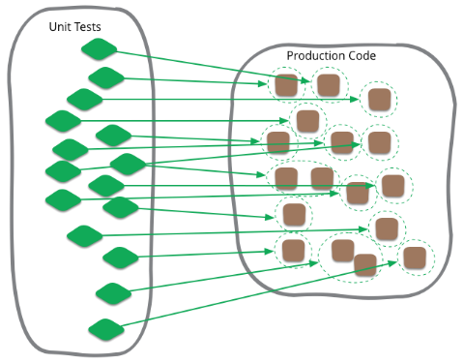

1. **Integration Testing:**

We performed integration testing to validate the interaction and compatibility of different modules when combined. This involved testing the integration points and verifying the smooth flow of data and communication between components.

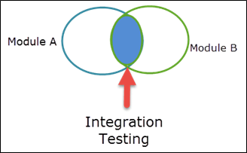

**4.4.2 Test Plans**

To execute the testing activities effectively, we developed detailed test plans that outlined the scope, objectives, and test scenarios for each type of testing. Our test plans included the following key elements:

1. **Test Objectives:**

We defined clear objectives for each type of testing, specifying what aspects of the system would be tested and the expected outcomes.

1. **Test Scenarios:**

We created test scenarios that covered various use cases and scenarios to ensure comprehensive coverage of the system's functionality.

1. **Test Cases:**

We documented detailed test cases for each test scenario, specifying the input values, expected results, and any preconditions or assumptions.

1. **Test Data:**

We prepared relevant test data to simulate real-world scenarios and validate the system's behaviour under different conditions.

**4.5 Maintenance**

Maintenance is very necessary part for any software, it will include details on the support and maintenance activities required to keep the application up and running, as well as any updates or modifications planned for the future. Here are the points which we are operating.

1. **Regular Updates and Patches:**

Planed for timely updates to address bugs, security vulnerabilities, and feature enhancements through GitHub Pages.

1. **System Documentation:**

Maintained comprehensive documentation for system architecture, design, and user instructions (mentioned on GitHub).

1. **Bug Tracking and Issue Management:**

Implemented a system to track and resolve reported bugs and issues efficiently with the help of GitHub.

1. **Version Control and Source Code Management:**

Used GitHub version control systems for code management and collaboration.

**CHAPTER 5. RESULTS AND DISCUSSIONS**

**5.1 User Interface Representation**

The user interface of D-Controller is designed to provide the user with a comprehensive set of tools for drone control and monitoring. The application is divided into various modules, which include real-time telemetry data, drone mode, drone parameters, mission planning, map view, and video feed. The modules are arranged in a user-friendly interface with easy-to-use controls and buttons.

**5.1.1 Various Modules of the System**

1. **Real-time telemetry data**:

This module provides real-time information on the drone's status, including altitude, speed, GPS location, battery life, and sensor readings.

1. **Drone mode:**

This module allows the user to change the drone's mode of operation, including take-off, landing, and various flight modes such as manual, altitude hold, and GPS.

1. **Drone parameters:**

This module allows the user to change the drone's parameters, including maximum altitude, speed, and distance.

1. **Mission planning:**

This module allows the user to plan and execute autonomous missions with the drone, including setting waypoints and mission parameters.

1. **Real-Time Map Display:**

The real-time map display module integrated a map interface, utilizing the Leaflet Map API. It showed the current location of the drone in real-time, allowing users to visualize its position and track its movement during flight operations.

1. **Real-Time Waypoint Drawing:**

This module allowed users to draw waypoints directly on the map, defining the flight path visually. Users could simply click on the map to add waypoints and adjust their positions as needed. The feature provided a user-friendly way to plan missions accurately.

1. **Real-Time Video Feed:**

The real-time video feed module displayed the live video stream captured by the drone's onboard camera. Users could view the surroundings from the drone's perspective, enhancing situational awareness during flight operations.

**5.2 Snapshots of the System**

Screenshots of the D-Controller application.

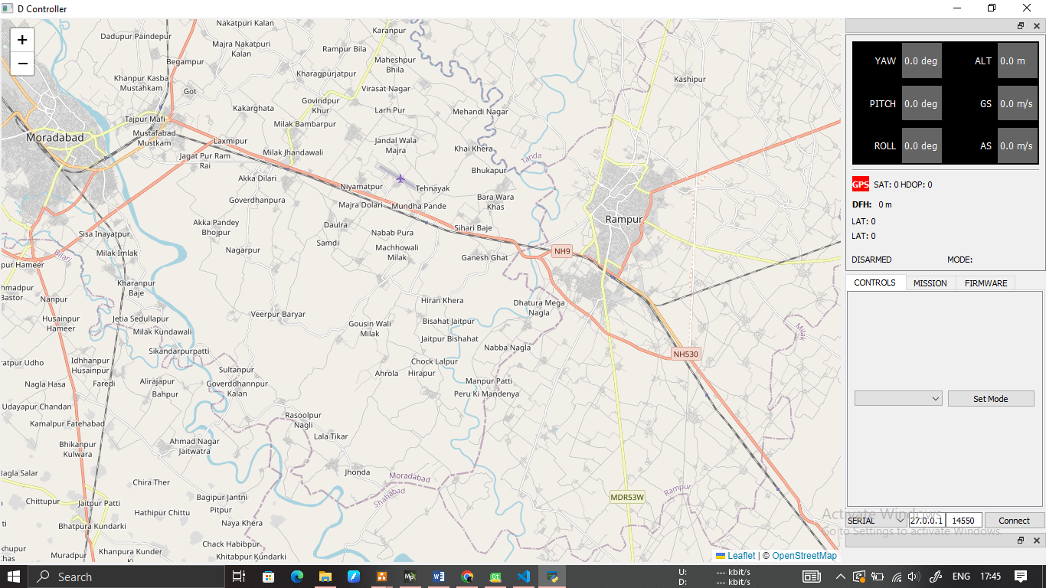

*Figure 5.1 shows the main menu with options to access various modules of the application.*



*Figure 5.2 shows the real-time telemetry data module, providing live information about the drone's status.*

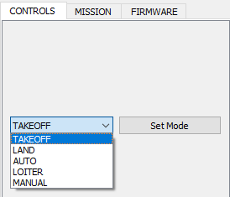

*Figure 5.3 shows the drone mode module, allowing the user to change the drone's mode of operation.*

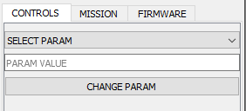

*Figure 5.4 shows the drone parameters module, allowing the user to change various drone parameters.*

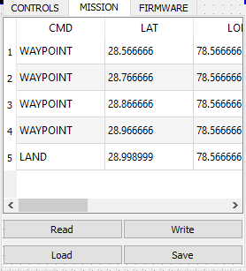

*Figure 5.5 shows the mission planning module, allowing the user to plan and execute autonomous missions with the drone.*

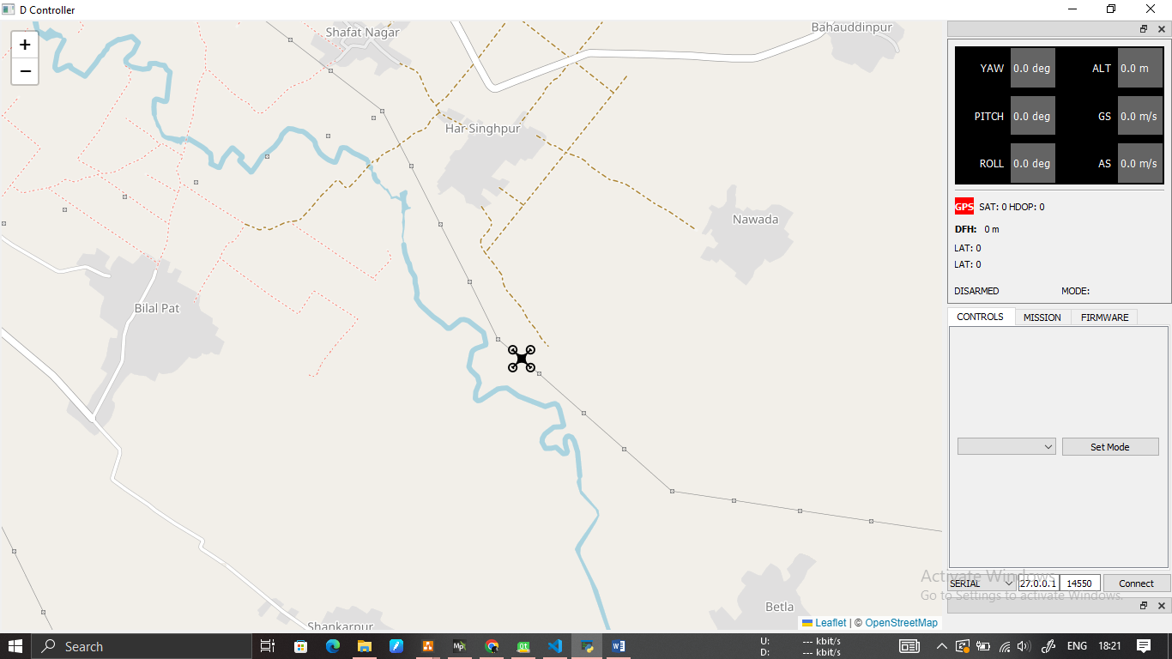

*Figure 5.6 shows the map view module, displaying real-time drone location on a map and allowing the user to draw waypoints and paths for the drone.*

**5.3 Back Ends Representation (Database to be used)**

The D-controller project does not require a dedicated database for backend storage. However, it utilizes data structures and files to store and retrieve information such as mission plans, user preferences, and telemetry data.

These data structures are managed and accessed by the system's components, ensuring efficient data handling and retrieval.

**CHAPTER 6. CONCLUSION AND FUTURE SCOPE**

**6.1 Conclusion**

In this project, we developed D-controller, a ground control station (GCS) to remotely control a drone.

The system was implemented using dronekit, pymavlink, and PyQt5 libraries, allowing real-time telemetry data, drone mode and parameter changes, mission planning, and live video feed of the drone.

The system also displayed the real-time drone location on a map and allowed real-time waypoint drawing.

Through this project, we have achieved the following:

1. **Real-Time Telemetry Data:**

The system effectively displayed real-time telemetry data, allowing users to monitor crucial flight parameters and drone status.

1. **Drone Mode Control:**

Users could seamlessly switch between different flight modes, providing flexibility in drone operations based on specific requirements.

1. **Drone Parameter Adjustment:**

The system facilitated the adjustment of various drone parameters, enabling customization of flight characteristics and behaviour.

1. **Mission Planning:**

Users could create and execute mission plans by defining waypoints and actions for autonomous flight operations.

1. **Real-Time Map Integration:**

The integration of the Leaflet Map API provided a real-time map display, showing the drone's location and enhancing situational awareness.

1. **Waypoint Drawing:**

Users could draw waypoints directly on the map, simplifying the mission planning process and ensuring accurate flight paths.

1. **Real-Time Video Feed**:

The system streamed live video from the drone's camera, enabling users to view the surroundings from the drone's perspective.

The successful implementation of these features demonstrates the effectiveness and usability of the "D-controller" GCS.

The system offers a comprehensive solution for drone control and monitoring, enhancing operational capabilities and ensuring a smooth user experience.

**6.2 Future Scope**

While the current version of the "D-controller" project meets the initial objectives, there are several potential areas for future enhancements and expansions:

1. **Advanced Flight Modes:**

Incorporate additional flight modes, such as follow-me mode, orbit mode, and waypoint-based dynamic missions, to extend the capabilities and versatility of the system.

1. **Advanced Mission Planning:**

Enhance the mission planning module with more sophisticated features, including geofencing, obstacle avoidance, and automated survey patterns for various applications.

1. **Advanced User Interface:**

Improve the user interface by incorporating more intuitive controls, visualizations, and interactive elements to enhance the user experience and streamline the workflow.

1. **Integration with AI and Machine Learning:**

Explore the integration of artificial intelligence (AI) and machine learning algorithms to enable advanced functionalities, such as object detection and tracking, autonomous decision-making, and intelligent mission planning.

1. **Collaborative Features:**

Implement collaborative features that enable multiple users to control and monitor the drone simultaneously, facilitating teamwork and collaborative missions.

1. **Integration with Cloud Services:**

Explore the integration of cloud services to store and analyse flight data, provide remote access and control, and enable data sharing and collaboration among multiple users.

1. **Enhanced Security:**

Strengthen the system's security measures, including user authentication, data encryption, and secure communication protocols, to ensure the privacy and integrity of the drone control operations.

By pursuing these future enhancements and considering the evolving needs of the drone industry, the "D-controller" GCS has the potential to become a comprehensive and advanced platform for drone control, offering increased functionality, usability, and scalability.

**REFERENCES/BIBLIOGRAPHY**

1. ArduPilot. (2021). ArduPilot Copter Documentation.

Retrieved from https://ardupilot.org/copter/docs/index.html

2. Dronekit. (2021). Dronekit-Python Documentation.

Retrieved from <https://dronekit->python.readthedocs.io/en/latest/

3. OpenCV. (2021). OpenCV Documentation.

Retrieved from https://docs.opencv.org/4.5.2/

4. PyQt. (2021). PyQt Documentation.

Retrieved from https://www.riverbankcomputing.com/static/Docs/PyQt5/

5. Pymavlink. (2021). Pymavlink Documentation.

Retrieved from https://www.ardusub.com/developers/pymavlink.html

6. Python Software Foundation. (2021). Python 3.9.2 Documentation.

Retrieved from https://docs.python.org/3/

7. Stack Overflow. (2021). Retrieved from https://stackoverflow.com/

8. GitHub. (2021). Retrieved from https://github.com/

**APPENDIX A: DEVELOPMENT ENVIRONMENT**

**A.1 Hardware Requirements**

For the development of the "D-controller" GCS application, the following hardware requirements should be met:

1. A computer system with an Intel Core i3 or equivalent processor is recommended for optimal performance.
2. Need at least 4GB of RAM to ensure smooth operation.
3. Allocating minimum of 256GB SSD storage to accommodate the development tools and project files.
4. To handle graphical rendering tasks, an integrated or dedicated GPU with OpenGL support is required.
5. It is recommended to have a screen size of 15 inches or larger for comfortable coding and testing.

**A.2 Software Requirements**

To create the "D-controller" GCS application, will need the following software tools and libraries:

1. Choosing an operating system such as Windows 10, macOS, or a Linux distribution like Ubuntu.
2. Need to have Python 3.7 or a later version installed in our system
3. Selecting an Integrated Development Environment (IDE) that suits our preferences, such as Visual Studio Code or PyCharm.
4. Install Qt Designer, a helpful tool for designing the user interface of your application.
5. Set up Git, a version control system, to track changes and collaborate with others.
6. Install the Dronekit Python library to establish communication with the drone.
7. Use the PyMavlink Python library to handle MAVLink messages.
8. Install the PyQt5 library, which provides Python bindings for the Qt framework.
9. Include the OpenCV library for powerful computer vision and image processing capabilities.
10. Obtain the Leaflet Map API JavaScript library for integrating interactive maps into your application.

**A.3 Development Setup**

To set up development environment for the "D-controller" GCS application, follow these steps are needed:

1. Begin by installing our chosen operating system on our computer system.
2. Install Python 3.7 or a later version and ensure that it is added to our system's PATH variable.
3. Select and install your preferred IDE, such as Visual Studio Code, ensuring it is properly configured for Python development.
4. Install Git and create a Git repository to manage version control for your project.
5. Use the pip package manager to install the required Python libraries by executing the following commands:

* pip install dronekit
* pip install pymavlink
* pip install pyqt5
* pip install opencv-python

1. Download Qt Designer from the official Qt website and install it on your system.
2. Obtain the Leaflet Map API JavaScript library and include it in the HTML file of your project.

By following these steps, we will have successfully set up your development environment for building, testing, and deploying the "D-controller" GCS application.